CHAPTER 10: Heat and electricity
Worksheet 10.7

Ohm’s Law
Science Quest 9: pages 369–71
Student: Class:

1. The following circuit was constructed to investigate Ohm’s Law using two different resistors. The results of the two experiments are shown in the table below.
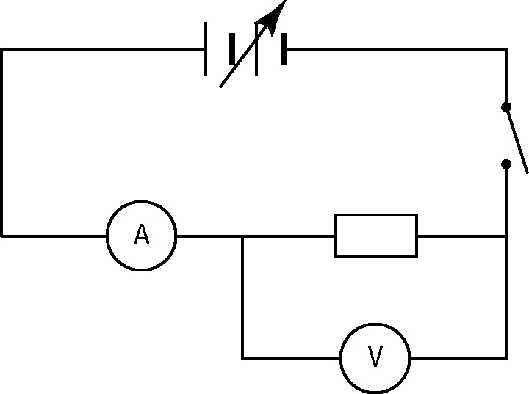
Resistor | Voltage (V) | Current (A)
X | 0 | 0
 | 2 | 2.0
 | 4 | 4.0
 | 6 | 6.0
 | 8 | 8.0
Y | 0 | 0
 | 2 | 2.7
 | 4 | 5.3
 | 6 | 8.0
 | 8 | 10.7

(a) On the grid below plot line graphs of Current (vertical axis) versus Voltage for each resistor. Draw the line of best fit.


(b) Explain how these graphs demonstrate Ohm’s Law.

CHAPTER 10: Heat and electricity
Worksheet 10.7

Page 2

(c) Use the graphs to calculate the resistance of each resistor.

2. The experiment was repeated but this time the resistor was replaced by a light globe.
The results are shown below right.
(a) Draw a line graph of this data and draw the line of best fit.
V  (V) | I  (A)
0 | 0
2 | 2.0
4 | 4.0
6 | 5.7
8 | 7.0
10 | 7.8


(b) Describe how the current changes as the voltage increases.

(c) Account for the trend in the data.

